**ASP NET CORE WEB API RUN IN DOCKER**

1. **Creating Project**

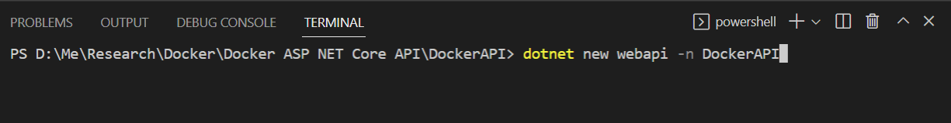

Docker new webapi -n “<ProjectName>”

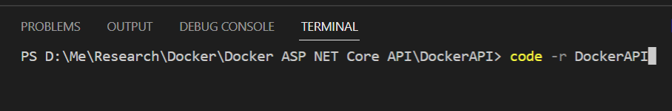

Code -r DockerAPI

The above command in order to launch the project code in VSCode

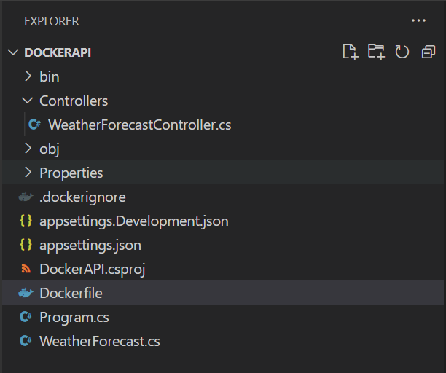

dotnet build

dotnet run

The above command in order to build and run the WebAPI Application

1. **Docker Configuration**

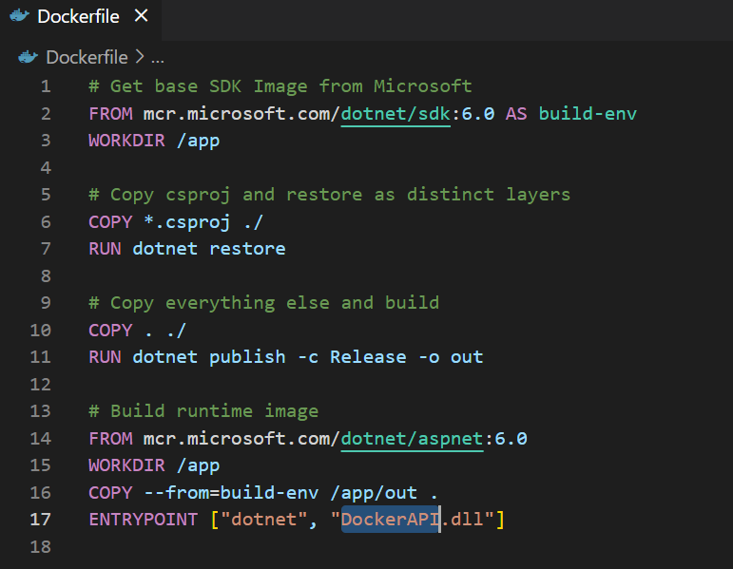

Create Dockerfile and copy paste the code

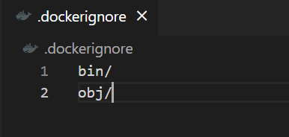

Create .dockerignore

After that create docker image for ASPNET.Core Web API

docker build -t <hub id>/<image name>:version (Format)

docker build -t muhkhoirudin/dockerapi . (it will refers to latest image version)

docker images (in order to see all images we have)

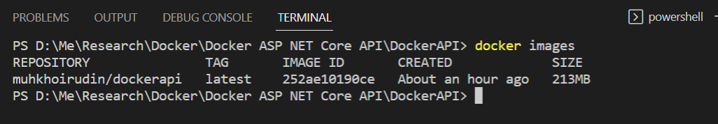

docker run -d -p <port:80 --name <image name>

docker run -d -p 8089:80 --name dockerapi muhkhoirudin/dockerapi (run docker image)

Your application will run at port 8089 “http://localhost:8089/WeatherForecast”

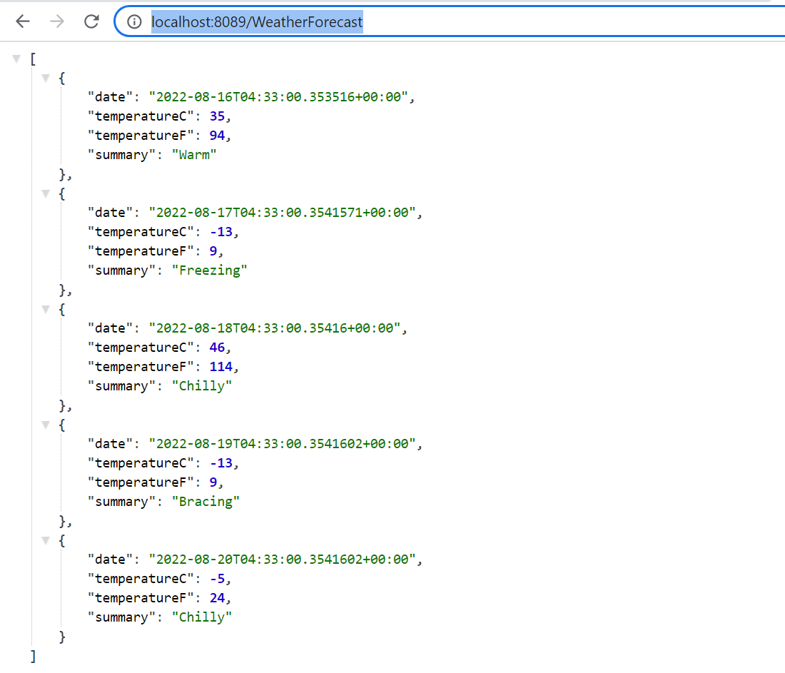

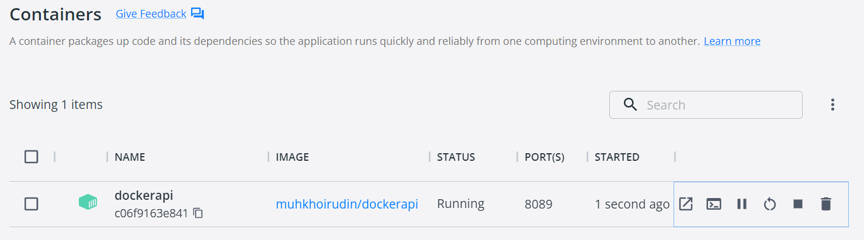

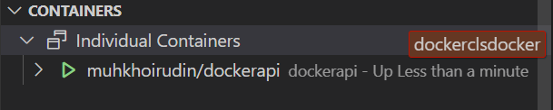

**Stop docker image**

docker stop dockerapi (or u able to change docker name with docker unique ID)

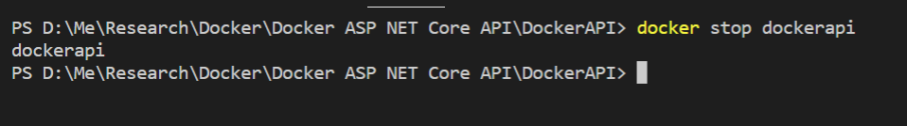

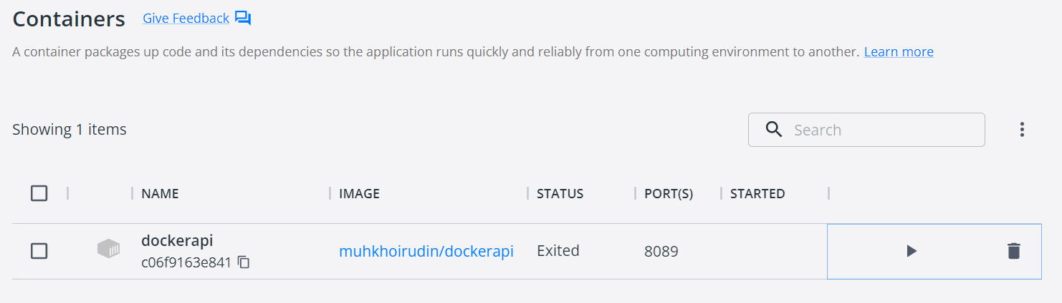

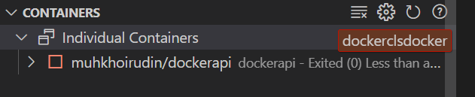

**Start docker image** (or u able to change docker name with docker unique ID)



**Push Image to Docker Hub**

docker push muhkhoirudin/dockerapi

